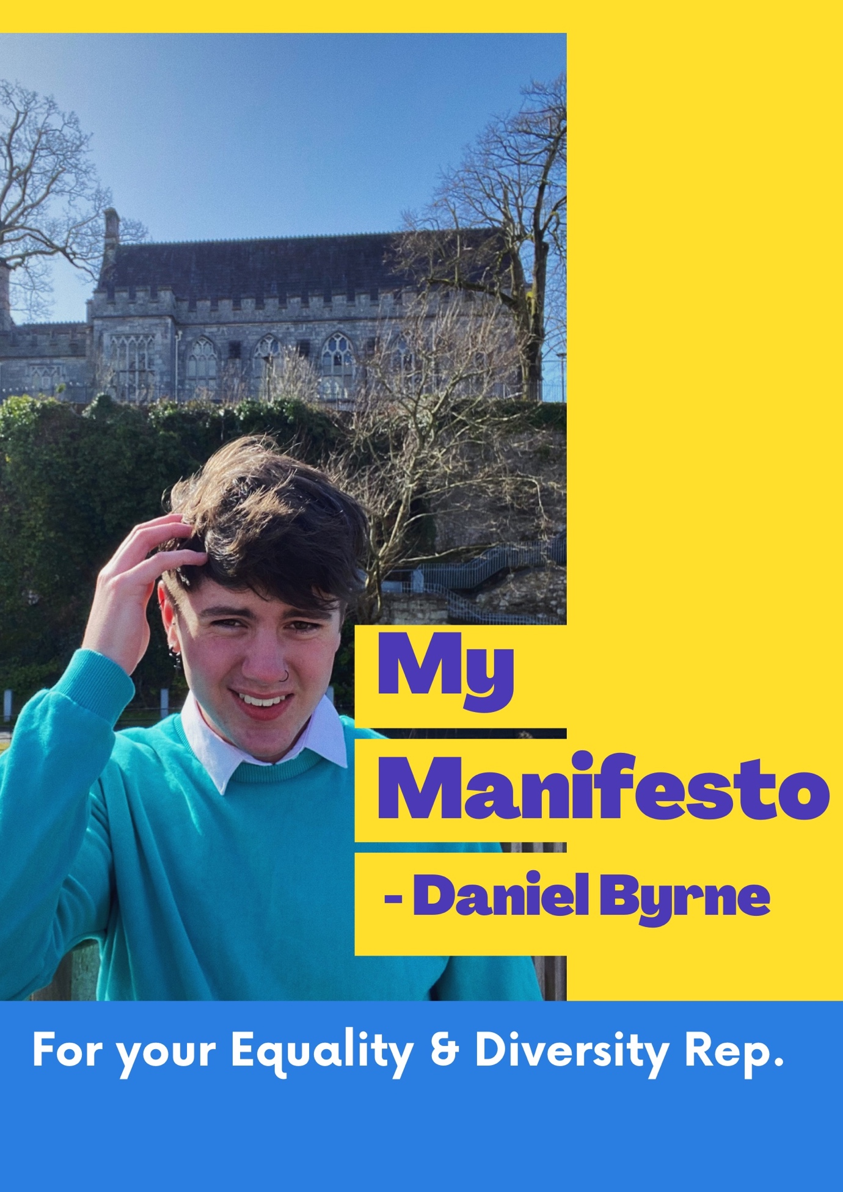

About Me:
Hello! I’m Daniel Byrne. I am a second year Government and Political Science student and a candidate to be your Equality and Diversity Representative. It is my hope that you will consider me in the upcoming SU elections from the 29th-31st. I am a fresh face in the student union politics scene with fresh ideas and perspectives. One of the main reasons I am running for this position is to ensure that U.C.C. remains a safe and inclusive space for all its students. I am extremely passionate about helping and empowering people and I hope that my goals here will reflect that. As a politics student and enthusiast myself I have extensive knowledge in the field of social injustice and the often overlooked issue of intersectionality. I have spoken at events raising awareness for the obstacles students face in terms of their mental health and after receiving the position of Entertainments Rep. in my course last year I have gained valuable experience in organising, planning and promoting events.

During my time in UCC, as a member of the LGBTQ+ community, I have had incredible opportunities and have had the luxury of navigating through campus with extraordinary ease, this is mostly thanks to the fantastic work of the Equality Working Group who work tirelessly to ensure that all students have a similar experience. If elected I want to return the favour, unfortunately, a lot of this work goes unnoticed, I plan to highlight the operations and achievements of the group and strengthen the relationship it has with the student body. Increasing the visibility of the EWG makes it easier for students to approach them with issues or ideas and thus the group can run more efficiently.

Duties of the Equality Rep:
The role and responsibilities of the Equality Rep entails the general promotion of equality around the University, however, in addition to this, as the Rep I would;
- Establish, chair and develop the EGW.
- Represent the opinions and stances of the EGW at UCCSU Executive meetings.
- Implement my own plans and take on the ideas of other students to improve the quality of life on campus.

The uncertainty of the Coronavirus pandemic is a valid cause for stress and anxiety, however, the next academic year looks to be the bright with the rollout of numerous vaccines. In any scenario, I aim to carry out my duties and responsibilities as Equality and Diversity Rep efficiently and effectively. Here I have outlined my key goals and aspirations for working with the following groups and key areas:

Racial and Ethnic Minority Students:
One of my top priorities if elected will revolve around supporting and empowering students of all racial and ethnic minorities.

- I aim to do so by acquiring more funding for culturally focused societies and by increasing the promotion and recognition of POC led initiatives and events. This would entail numerous events that feature a variety of cultures, countries and creeds that are represented here in UCC. I aim to work with the Entertainments Officer and the various International Societies to achieve this.
- It is also vital to boost awareness of issues regarding racism ranging from individual microaggressions to widespread institutionalised racism. This is especially prevalent in cases of intersectionality where discrimination may overlap, I would like to see a programme in place to educate our students about this issue specifically as it does not receive enough attention.

LGBTQ+ Students:
LGBTQ+ issues are something I hold near and dear, If elected I plan to continue the work of ensuring UCC is a safe and inclusive space for all its LGBTQ+ students. For our trans students specifically, creating a friendly and respectful environment on campus for people of all gender identities is pivotal.
- Growing up as a member of the LGBTQ+ community (or any minority for that matter) comes with its own hardships and obstacles, this must be acknowledged and for that reason I aim to attain counselling specifically tailored to the needs of such students. This can be achieved through enlisting counsellors with this specific area of expertise, or making use of a third party counselling service to facilitate this virtually. This would of course be free of charge.
- In addition to this I plan to put my Ents Rep. skills to use by promoting and aiding the organisation of multiple LGBTQ+ events and initiatives.

Students with Disabilities
There is always room for improvement when it comes to accessibility in the university for our neurodivergent students. This not only applies the work done within the classroom but the entire college lifestyle too. It is crucial that our campus is accessible to everybody.
- I aim to ensure that students with disabilities can participate in all aspects of college life here in UCC with ease. This includes Freshers Week, RAG week, Careers Fairs and any other event organised by the Union or a third party.
- I would also like to spend this year aiding off campus disability focused charities and organisations with on campus events and fundraisers.

Ensuring Gender Equality amongst students:
Thankfully, UCC doesn’t fail to produce a variety of strong women candidates from class reps to SU elections, that being said it is still important to promote women’s involvement in politics both in and outside of campus.
- I will continue the work of the previous Students Unions on encouraging women to get involved in student politics to maintain this impressive level of participation.
- It is fundamentally important that women can feel safe in UCC. There has been many campaign’s ran on campus to deal with the sensitive issue of sexual assault and have done so to a tremendous effect. Such campaign’s include “Don’t be that Guy” and “Consent is Sexy”. I would be more than happy to organise and run these campaigns once again. This is especially crucial on much more marginalised groups of women such as trans women of colour, who are also at severe risk.

Mental Health Awareness:
Fortunately, UCC has a wide variety of services available to students who are struggling with mental health, the task at hand is to ensure students are aware of these services and feel comfortable enough to avail of them. I plan to continue and develop the incredible work the SU have done in promoting mental health awareness for all students, whether it be facilitating more counselling sessions, altering the format of such sessions to suit some people, or orchestrating events both during and outside of Mental Health Week.

Mature Students:
- It would be fair to say that most events in UCC are catered to a younger audience of students, and although these events may be suited to some mature students, it is not always the case. I would like to once again work with the Entertainments officer to organise and develop events that focus on mature students.

Most importantly, I want to engage with you and take your insights and ideas on board, let’s make this a collective experience!

Thank you for taking the time to read through my manifesto, please if you have any questions or queries, don’t hesitate to contact me!

Is mise le meas,
Daniel.

