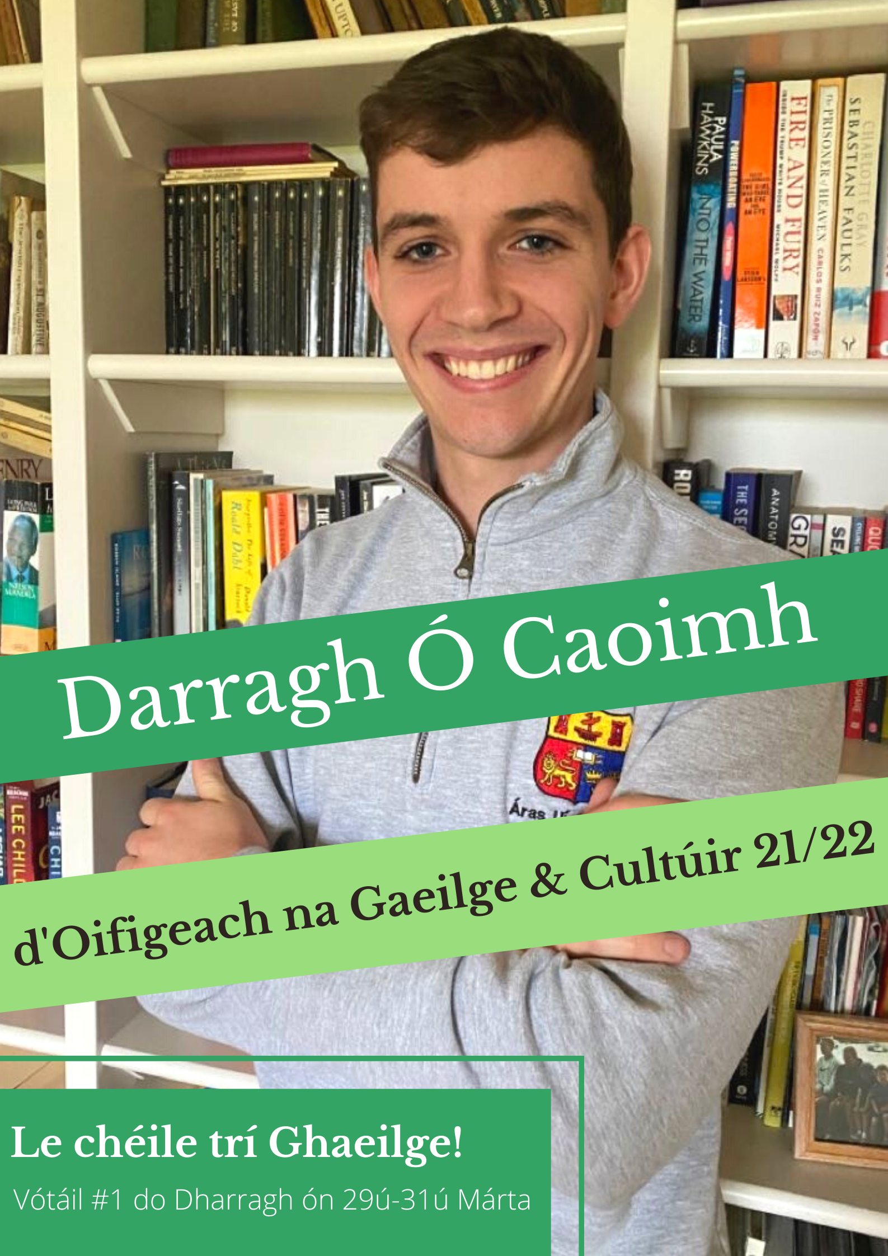
Forógra Toghcháin
Election Manifesto

Darragh Ó Caoimh – Iarrthóir d’Oifigeach Gaeilge agus Cultúir
Darragh Ó Caoimh - Candidate for Irish and Culture Officer

Is mise Darragh Ó Caoimh. Is as Ceann Toirc i gCorcaigh ó dhúchas mé. Mac léinn
le Dlí agus le Gaeilge is ea mé agus trí bliana déanta anois agam beagnach. Táim i
lár an aonaigh ó thaobh na Gaeilge de ó tháinig mé go UCC in 2018 agus baint
agam le gach gné den teanga san ollscoil agus lasmuigh dhi leis. Má thugann tú do
vóta #1 dom geallaim go gcuirfidh mé mo chroí is m’anam isteach sa chúram, le
cabhair ón dtaithí ar fad atá agam agus na daoine gur chuireas aithne orthu.

My name is Darragh Ó Caoimh. Born and raised in Kanturk, Co.Cork, I’m a third-
year Law & Irish student here in UCC. Since coming to college in 2018, I have been
at the heart of campus life as Gaeilge and I have been involved with every aspect of
the language both inside and outside the walls of UCC. If you give me your #1 vote, I
am committed to putting my heart and soul into the position, with all the experience I
have and the people I have met to assist me in honouring this commitment.

Chónaíos in Áras Uí Thuama ar feadh an chéad dá bhliain den ollscoil. Lóistín
lánGhaeilge is ea an tÁras, agus chuireas aithne mhaith ar phobal na Gaeilge san
ollscoil le linn mo thréimhse ann. Táim ag aisteoireacht leis an gCumann
Drámaíochta le trí bliana anuas, agus tréimhsí curtha isteach ar choiste an
Chumainn sin agam. Toghadh mé mar Chathaoirleach na Cuallachta don bhliain
2019/2020. Bhí an-rath ar an gCuallacht an bhliain sin agus d’éirigh linn mórán a
bhaint amach. Go deimhin, bhaineamar duaiseanna náisiúnta ag Ardfheis Chonradh
na Gaeilge agus Comórtas Ghlór na nGael. Tá cairde agam ní hamháin in UCC ach
in ollscoileanna eile mórdtimpeall na tíre go léir tar éis na tréimhse sin. Tá dhá
bhliain caite agam chomh maith i mo bhall de Choiste Gnó Bhord na Gaeilge agus
aithne mhaith agam ar fhoireann Roinn na Gaeilge agus Ionad na Gaeilge
Labhartha, rud atá ríthábhachtach don phost seo dar liom.

I lived in Áras Uí Thuama for my first and second year of college. The Áras in an all-
Irish-language accommodation scheme and I really got to know the university’s Irish
language community during my time there. I have been an actor with the Cumann
Drámaíochta for three years now, and I have been on that society’s committee
during that time. I was elected Chair of the Cuallacht for the 2019/2020 term. The
society was extremely successful that year, having achieved many of our aims and
more. We won national prizes at Conradh na Gaeilge’s Ardfheis and in the Glór na
Gael competition. I made great friends during this time, not only from UCC but from
universities all over the country. I have spent two years as a member of Coiste Gnó
Bhord na Gaeilge, the university’s Irish-language affairs committee, and have got to
know the staff at Roinn na Gaeilge and Ionad na Gaeilge Labhartha, experience I
believe to be crucial for this position.

Tá dua agus dúthracht caite agam leis an nGaeilge lasmuigh den ollscoil chomh
maith. D’oibríos i gColáiste UISCE i Maigh Eo ceithre shamhradh as a chéile agus
thugas tamall i gCorca Dhuibhne i mbun ceannaireachta chomh maith. Toghadh mé
le déanaí ar Choiste Gnó Chonradh na Gaeilge, an eagraíocht náisiúnta Gaeilge.
Thugas tréimhse ag cruthú ábhar ar líne do “GaeltachtX”, togra de chuid Chonradh
na Gaeilge a cuireadh ar bun an samhradh seo caite ar Instagram. Bím ag scríobh
filíochta agus bhíos ar dhuine d’eagarthóirí na hirise Breac d’fhoilsigh an Chuallacht
agus Motley níos túisce an mhí seo.

My experience with Irish extends beyond UCC too. I spent four summers working as
a cinnire or leader in Coláiste UISCE in the Mayo Gaeltacht and most recently in
Corca Dhuibhne (West Kerry Gaeltacht). I was recently elected to Conradh na
Gaeilge’s Executive Committee, the national Irish-language organisation. I spent
time creating online content for “GaeltachtX” - a project run by Conradh na Gaeilge
last summer on Instagram. I am a poet and was one of the editors for Breac, the
magazine that was published by an Chuallacht and Motley earlier this month.
Chabhródh an taithí seo ar fad agus an tuiscint atá agam ar phobal Gaeilge na
hollscoile go mór liom dá dtoghfaí mé. Tá fúm pobal UCC a thabhairt le chéile trí
Ghaeilge agus iarraim ort do vóta #1 a thabhairt dom ón 29 – 31 Márta.

If elected, both my understanding of the Irish community in UCC and all of my
experiences to date will stand to me greatly. I want to bring the UCC community
together through Irish - an Ghaeilge - and I am asking you to please vote #1 for me
from 29 - 31 March.

#LeChéileTríGhaeilge
Seo iad na clocha is mó a bheidh ar mo phaidrín má thugann tú VÓTA #1 dom;

⇒ Scéim nua teanga don ollscoil – ní raibh aon cheann nua ó 2006!
⇒ Café na Gaeilge a bhunú ar campus.
⇒ Ceachtanna Gaeilge a chur ar fáil do dhaltaí meánscoile faoi mhíbhuntáiste.
⇒ An iris Gaeilge Breac a dhéanamh buan bliantiúil.
⇒ Comórtas bréagchúirte a bhunú agus na comórtaisí díopóireachta a bhuanú.
⇒ Céilithe agus rince seite a dhéanamh ag Seachtain na bhFreisear, Seachtain na
nGiobal srl.
⇒ Bál na Gaeilge agus Seó Drag a chur ar siúl.

The following will be my priorities if you give me your #1 VOTE;
⇒ A new language scheme for the University - there has not been an update
since 2006!
⇒ To establish a Café Gaeilge (Irish-language café) on campus.
⇒ To offer Irish classes for disadvantaged second-level students.
⇒ To make Breac magazine a permanent annual publication.
⇒ To establish a moot court competition and to make the debating competitions
a permanent fixture.
⇒ To organise a céilí and set dancing at events like Freshers and RAG week,
etc.
⇒ To have Bál na Gaeilge (Irish-language ball) and to hold a Drag Show as
Gaeilge.

Scéim Teanga nua a thabhairt isteach don Ollscoil.
Tabharfaidh mé tús áite do réiteach scéim teanga don Ollscoil. An rud atá i gceist le
scéim teanga ná cur síos ar na seirbhísí agus tacaíochtaí Gaeilge a chuirfidh an
ollscoil ar fáil do na mic léinn agus daoine eile. In 2006 a cuireadh an ceann
deireanach le chéile, cúig bliana déag ó shin! Tá géarghá le scéim nua chun feabhas
a chur ar chás na Gaeilge san ollscoil agus chun seirbhísí agus cearta teanga a
chinntiú.

Introduce a New Irish-Language Scheme for the Univeristy
I will prioritise the creation of a new Irish-language scheme for the University. A
language scheme describes the services and supports for Irish that the University
will provide for students and for others. The previous scheme was set in 2006, 15
long years ago! A new scheme is crucial for Irish to thrive within the University and to
guarantee language rights and services.

Café na Gaeilge
Cuirfidh mé tús le feachtas do ‘Café na Gaeilge’, faoi mar atá ag Ollscoil na
hÉireann, Gaillimh. Cé go mbíonn an Seomra Caidrimh san ORB ar fáil do mhic
léinn ag amanna faoi leith, teastaíonn áit a bheadh oscailte ar feadh an lae ar nós
The Coffee Dock. Áit a bhféadfá bualadh le do chairde agus Gaeilge a labhairt leo,
áit a labhrófaí Gaeilge leat is tú ag íoc.

Irish Café
I will begin a campaign for ‘Café na Gaeilge’ similar to that of NUIG. Though the
Seomra Cairdrimh in the ORB is available to students at certain times, a place is
needed that would be open all day such as The Coffee Dock. This would be a place
to meet friends and to speak Irish with them, where you could speak Irish while
ordering and paying.

Meitheal na Gaeilge
Bunóidh mé grúpa nó ‘meitheal’ daoine chun obair dheonach a dhéanamh i measc
an phobail. Tá mórán scoláirí Ardteiste agus daltaí meánscoile nach bhfuil
d’acmhainn acu íoc as ceachtanna Gaeilge nó ‘grinds’.
Ach is féidir linne beagán d’ár gcuid ama agus d’ár gcuid scileanna teanga a roinnt
leo chun lámh chúnta a tabhairt dóibh. Oibreoidh mé i gcomhar leis an Ollamh
Pádraig Ó Macháin chun é seo a chur i gcrích.

Irish Academic Support Group for Secondary School Students
I will establish a group or a ‘meitheal’ to undertake volunteer work in the community.
Many Leaving Cert students cannot afford to pay for Irish lessons or grinds.
We, however, can share a little of our time and our language skills with them to help
support their learning. I will work with Prof. Pádraig Ó Macháin to achieve this.

Comórtais Díospóireachta agus Bréagchúirte
Dhein an Chuallacht gaisce i mbliana agus chuireadar comórtas díospóireachta ar
bun den chéad uair le blianta. Cabhróidh mé leis an gCuallacht bonn níos láidre a
chur faoi seo agus imeacht buan bliantúil a dhéanamh de. Ina theannta sin,
reachtálfaidh mé bréagchúirt Gaeilge chun deis a thabhairt do mhic léinn dlí a gcuid
Gaeilge a chleachtadh, rud a chabhróidh leo ó thaobh fostaíochta de.

Debating and Mooting Competitions
The Cuallacht delivered strongly this year by organising the first debate competition
in years. I will help the Cuallacht make this an annual event. I will also organise an
Irish-language moot court to give law students an opportunity to practice their Irish in
a way that will assist with vocational and employable skills development.

Iris Gaeilge
Bhí sé de phribhléid agam a bheith ar dhuine d’eagarthóirí Breac, iris lán Ghaeilge a
d’fhoilsigh an Chuallcht an mhí seo i gcomhar le Motley. Ach tá baol ann nach
leanfaidh an obair sin ar aghaidh. Caithfimid foilseachán buanseasmhach a
dhéanamh de Breac, ar nós an UCC Express nó Motley, agus beidh mé ar mo chroí-
dícheall ag iarraidh é seo a bhaint amach.

Irish Magazine
I had the privilege of being one of the editors of Breac, an Irish-language magazine
that was published this month by the Cuallacht in collaboration with Motley.
However, there is a risk that this work will come to an end. Breac must be made a
permanent publication similar to UCC Express or Motley, and I will work hard to
make this happen.

Rince seite
Eagróidh mé céilithe ar campus agus ranganna damhsa do mhic léinn gur mhaith
triail a bhaint as cúpla steip, go háirithe le linn Seachtain na nGiobal, Seachtain na
bhFreisear, srl.

Set Dancing
I will organise céilís on campus (especially during RAG and Freshers) and dance
lessons for students wishing to try a shtep!

Bál na Gaeilge, Seó Drag, agus Imeachtaí eile.
Ba bheag nár éirigh liom féin agus coiste na Cuallachta Bál na Gaeilge a chur ar siúl
anuraidh ach d’fhág dúnadh tobann na hollscoile ar 12 Márta nach bhféadfaimis é a
chur ar siúl an oíche sin. Tuigim nach raibh Bál Gaeilge ann ó 2016! Déanfaidh mé
mo sheacht míle dícheall é a eagrú in 2021. Oibreoidh mé as lámha a chéile leis an
gCuallacht agus leis an gCumann Drámaíochta chun na himeachtaí seo agus eile a
reachtáil.
Bál na Gaeilge, Drag Show and other events.
Myself and the Cuallacht committee were very close to having Bál na Gaeilge last
year, but the sudden closure of the University on March 12 due to Covid-19 resulted
in the event being cancelled for that very night! I am painfully aware that a ball has
not occurred since 2016. I will work my very hardest to organise this in 2021. I will
work hand in hand with the Cuallacht and with the Cumann Drámaíochta to organise
these and other events.

